**Sharks as a Symbol of God**

**By Megan Townsend**

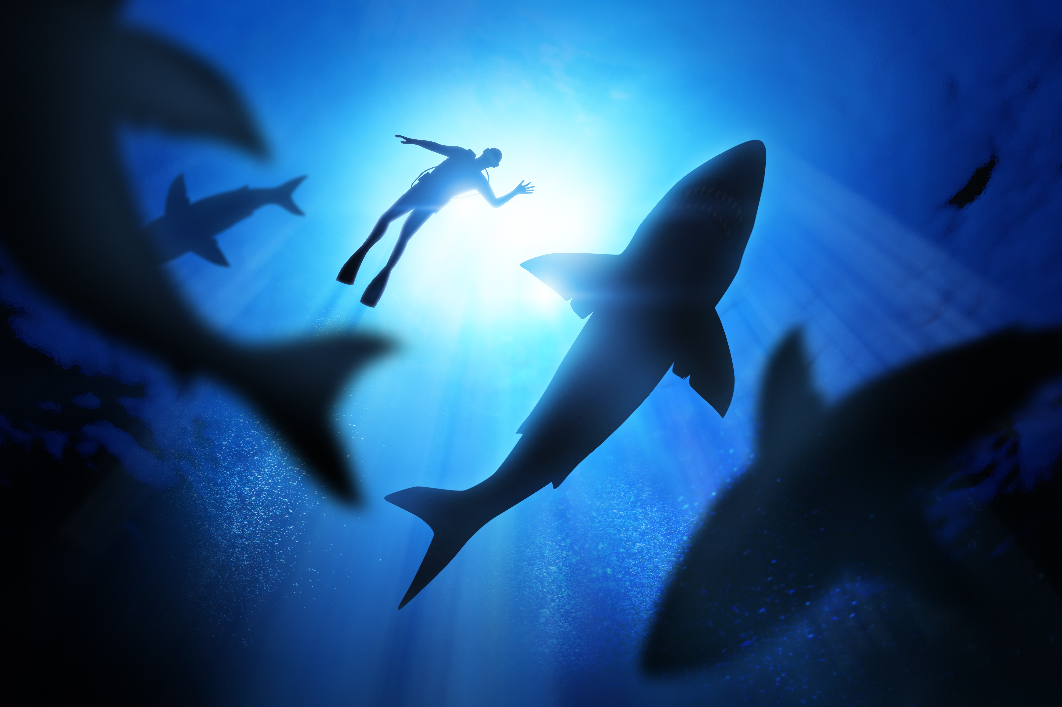

For most of my life, I have been afraid of sharks and I have been afraid of God. My mother and my grandmother are both strict Irish Catholics who are so afraid of sharks that they will not swim in the ocean. As a child in Catholic school, I learned of the gift of the Holy Spirit known as wonder and awe, or fear of the Lord. This split in language and meaning would come to define my relationship with God (and therefore all of the living world). Of course I learned it first as *fear of the Lord,* the gift that all good Catholic children should have: a virtue that instills a fear of the unknown, of the almighty power of God, of the dark night and the deep ocean where God’s creation and mystery lie. This virtue gave me an overactive imagination, the classic Catholic imagination that strives to see God and sacramental grace in all creatures. Sharks have always been the paramount of that grace. They represent well my relationship with my faith, but also my spiritual connection to the natural world and the way I experience God.

To possess the gift of the Holy Spirit that is wonder and awe is to have reverence, respect, and deep awe for God and God’s creation. Fear of the Lord is supposed to mean the same, but it makes a connection between fear and wonder. To stand before God’s creation and look is to be in awe, certainly, but also to be afraid, of its sheer magnitude and all that is unknowable. It is frightening in its history, how much older and stronger all of creation is than its human inhabitants. As a child, swimming in the ocean was both a spiritually rewarding and terrifying experience for me. I was haunted by waking images and dreams of sharks swimming under me without my knowing. Even now, I am in fear and awe at the physical act of submerging my body in water that contains all that I know about and so much more - it is this emptiness and the possibility of presence or absence that has always scared me. Now that I have learned about shark and ocean conservation, I know that an ocean without sharks is much scarier than an ocean full of them, and that plucks at the same fear. Looking at pictures of endless ocean gives me anxiety in a way that is worse than my nightmares about sharks: it is the same fear of doubt, of calling into God’s wilderness and finding it void.

Taking my first surfing lesson or floating too far from shore I imagined sharks bumping against my board or brushing against my dangling feet. It was like when I first read and felt Francis Thompson’s *The Hound of Heaven,* fleeing from my thoughts of being alone with God. The “labyrinthine ways of my own mind” encouraged my ceaseless imagination. I think my understanding of the gift of fear of the Lord only allowed me to feel close to creation through my fears. Regardless of the concept of the sacramental imagination, Catholics are not known for our reverence of the natural world (though there are excellent writers and encyclicals trying to bring us closer). Our fine points of ritual center around golden chalices and tabernacles, expansive stained glass, white clothing and purity. It was, therefore, a radical process for me to find God anywhere outside of Church buildings and crucifixes.

Aboriginal groups of Australia and the Kontu people of Papua New Guinea do understand how to relate prayer to daily life and ritual to the rhythms of the natural world. Sharks and rays in Aboriginal culture signified the generosity of ancestors and deities who filled the waters with powerful creatures and sources of food. The Kontu people became known to the West for their relationship with sharks after the 1982 documentary, *The Sharkcallers of Kontu.* The documentary follows a tribe that uses percussion to attract sharks, to be caught and used for food and raw materials. They even note in the documentary that their divine *Moroa* first created sharks, then created man and the relationship between them. The documentary includes a history of the Western colonization of Papua New Guinea, which condemned its shark catching practices as heretical magic and converted its people to Christianity. The evil of Western colonialism is endless, but notable here for ending a ritual in the name of religion and then continuing the practice of that ritual - devoid of anything sacred - to build a commercial fishing industry that over-harvests a finite, crucial element of ocean life.

It causes me to reflect again on the unnatural human urge to control God via the natural world. As a Kontu man, speaking to an Australian cameraperson, noted, sharks and the systems they inhabit were created long before humans. What better embodies the dichotomy of wonder or fear than the shark? Sharks allow us to experience fear and awe in the same breath; they force us to recognize our humility, our place in creation and our voyeurism into their world. There are plenty of animals that can teach us these things, but our obsession with sharks - attempting to capture sharks, film them, talk about them - makes this discovery prominent. They can also embody human cruelty in the name of control, as we expand human domain over one of the most predatory creatures in the world. We drag them behind speedboats for sport, cut off their fins for sale, slaughter them in the name of protection. Our fear of the sacred transforms into attempts to control or destroy it. There is something about the fear of creation that is pure, that levels humans with other animals in a way that Western society rarely glimpses. The danger enters when fear overwhelms wonder: when our fear of the Lord takes away our ability to be humbled, to be amazed.

*Megan Townsend is a Cofounding Editor at The Flood.*